Experiment 6 (b): Benchmarking of 5G/6G Communication for IoE Applications based on Throughput, Latency, Reliability and Energy Efficiency

Objective :
To simulate and compare the performance of 5G and 6G communication networks for Internet of Everything (IoE) applications based on the following parameters:
- Throughput: Amount of data successfully transmitted per second.
- Latency: Time taken for data to travel from sender to receiver.
- Reliability: Percentage of packets successfully delivered.
- Energy efficiency: Amount of energy consumed to transmit data.

Procedure :
- Open Google Colab and create a new notebook.
- Import the required Python libraries: NumPy, Pandas and Matplotlib.
- Define simulation parameters, including the number of packets, packet size, transmission rate, latency, packet delivery probability and energy consumption for both 5G and 6G.
- Generate simulated packet transmission data for each network.
- Calculate throughput, average latency, packet delivery ratio (PDR) and energy efficiency.
- Display the calculated performance metrics in a comparison table.
- Plot graphs comparing 5G and 6G performance.
- Analyse the results to determine which network performs better for IoE applications.
Python program code :

# Benchmarking of 5G/6G Communication for IoE Applications
# Metrics: Throughput, Latency, Reliability and Energy Efficiency

import numpy as np
import pandas as pd
import matplotlib.pyplot as plt

# Reproducible simulation
np.random.seed(42)

# Simulation parameters
N = 10000 # Number of packets
PACKET_SIZE = 1024 # Bytes per packet
TOTAL_BITS = N * PACKET_SIZE * 8

# Illustrative simulation assumptions (not measured network data)
networks = {
"5G": {
"rate_mbps": 100,
"latency_ms": 10,
"jitter_ms": 2,
"delivery_prob": 0.95,
"energy_mj": 0.8
},
"6G": {
"rate_mbps": 1000,
"latency_ms": 1,
"jitter_ms": 0.3,
"delivery_prob": 0.99,
"energy_mj": 0.5
}
}

results = []

for name, p in networks.items():
# Simulate packet delivery
delivered = np.random.random(N) < p["delivery_prob"]
successful_packets = int(np.sum(delivered))
delivered_bits = successful_packets * PACKET_SIZE * 8

# Simulate packet latency
latencies = np.random.normal(
p["latency_ms"], p["jitter_ms"], N
)
latencies = np.maximum(latencies, 0.01)
avg_latency = np.mean(latencies)

# Transmission duration based on offered data and link rate
transmission_time = TOTAL_BITS / (p["rate_mbps"] * 1e6)

# Performance metrics
throughput = delivered_bits / transmission_time / 1e6
reliability = successful_packets / N * 100

# Total illustrative energy consumed in joules
energy_joules = N * p["energy_mj"] / 1000

# Energy efficiency in megabits per joule
energy_efficiency = (delivered_bits / 1e6) / energy_joules

results.append({
"Network": name,
"Throughput (Mbps)": round(throughput, 2),
"Average Latency (ms)": round(avg_latency, 2),
"Reliability / PDR (%)": round(reliability, 2),
"Energy Efficiency (Mbit/J)": round(energy_efficiency, 2)
})

# Display results
df = pd.DataFrame(results).set_index("Network")
print("5G vs 6G PERFORMANCE COMPARISON")
print(df.to_string())

# Plot each performance metric
metrics = [
("Throughput (Mbps)", "Throughput (Mbps)"),
("Average Latency (ms)", "Average Latency (ms)"),
("Reliability / PDR (%)", "Reliability (%)"),
("Energy Efficiency (Mbit/J)", "Energy Efficiency (Mbit/J)")
]

fig, axes = plt.subplots(2, 2, figsize=(12, 8))

for ax, (column, ylabel) in zip(axes.flatten(), metrics):
df[column].plot(kind="bar", ax=ax)
ax.set_title(column)
ax.set_ylabel(ylabel)
ax.set_xlabel("Communication Network")
ax.tick_params(axis="x", rotation=0)
ax.grid(axis="y", linestyle="--", alpha=0.5)

plt.suptitle("Benchmarking of 5G and 6G for IoE Applications")
plt.tight_layout()
plt.show()

print("\nInterpretation:")
print("Higher throughput, reliability and energy efficiency are better.")
print("Lower average latency is better.")
print("Note: Results are simulated using illustrative assumptions,")
print("not measured performance of actual 5G or 6G networks.")
Output :
Table
DEVICE NO 200 | Offered Load | 38.40
DEVICE NO 200 | Throughput | 37.63
DEVICE NO 200 | Latency | 16.23 ms
DEVICE NO 200 | Reliability | 90.47 %
DEVICE NO 200 | Energy Efficiency | 6.28 Mbit/J
DEVICE NO 421 | Offered Load | 80.83 Mbps
DEVICE NO 421 | Throughput | 79.22
DEVICE NO 421 | Latency | 52.17 ms
DEVICE NO 421 | Reliability | 82.16 %
DEVICE NO 421 | Energy Efficiency | 4.36 Mbit/J
DEVICE NO 550 | Offered Load | 105.60 Mbps
DEVICE NO 550 | Throughput | 100.00 Mbps
DEVICE NO 550 | Latency | 200.00 ms
DEVICE NO 550 | Reliability | 77.30 %
DEVICE NO 550 | Energy Efficiency | 3.61 Mbit/J
DEVICE NO 673 | Offered Load | 129.22 Mbps
DEVICE NO 673 | Throughput | 100.00 Mbps
DEVICE NO 673 | Latency | 200.00 ms
DEVICE NO 673 | Reliability | 72.67 %
DEVICE NO 673 | Energy Efficiency | 3.04 Mbit/J
DEVICE NO 800 | Offered Load | 153.60  J
DEVICE NO 800 | Throughput | 100.00 Mbps
DEVICE NO 800 | Latency | 200.00 ms
DEVICE NO 800 | Reliability | 67.89 %  Energy
DEVICE NO 800 | Energy Efficiency | 2.57 Mbit/J

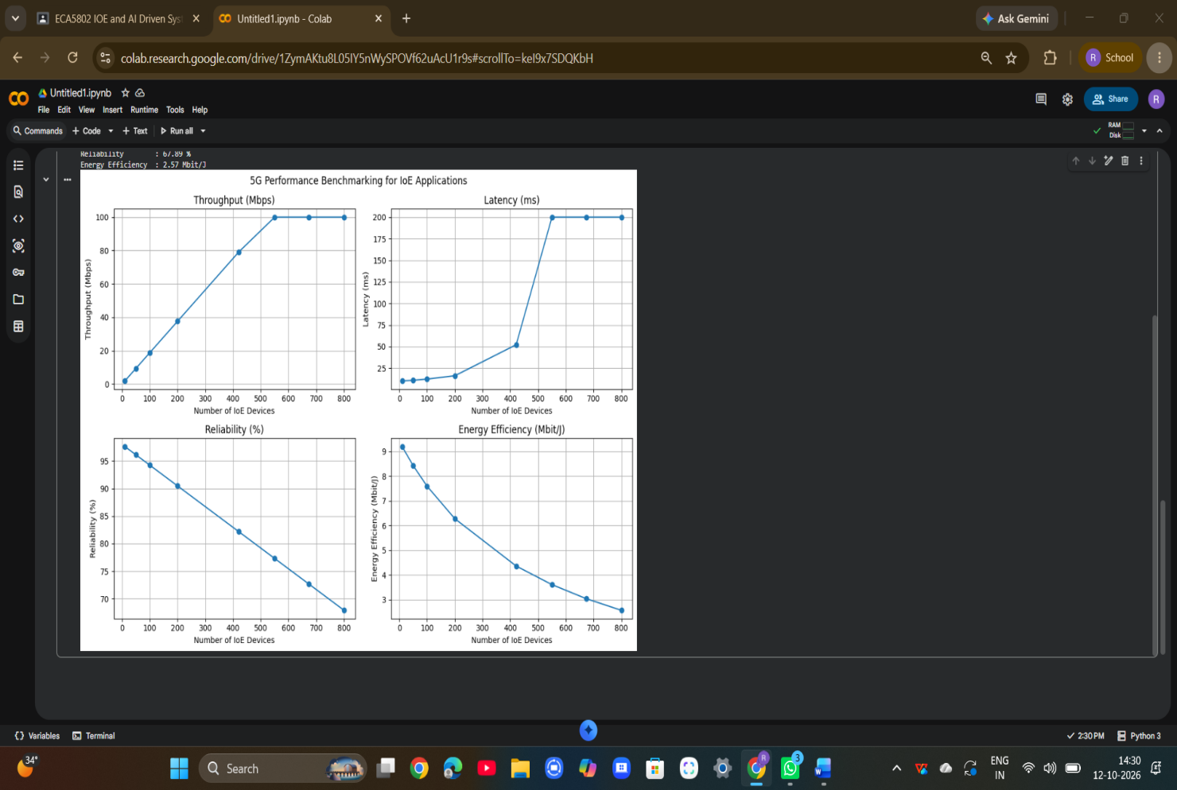

Result :
The 5G and 6G networks were simulated and compared based on throughput, latency, reliability, and energy efficiency. Under the assumed simulation parameters, 6G showed better overall performance for IoE applications.

